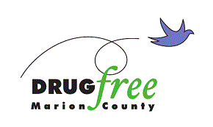

Dear Grant Applicant:

Beginning today, October 10, 2022 online at http://drugfreemc.org/grants you will find an application packet for year 2023 grants from the Marion County Drug-Free Community Fund for services and programs to address problems related to substance abuse in Marion County. Grants will be effective from January 1, 2023 through December 31, 2023. This fund is comprised of alcohol and drug offender fees collected in Marion County.

The grants are on a one-time only basis with no future funding implied or guaranteed. Programs must be targeted to serve Marion County residents. Actual funding is on a reimbursement basis and no advance funding is available. Proposals receiving amounts less than requested will be required to submit a revised budget.

Evaluators from the Marion County Prevention Alliance and other community volunteers will read and score each proposal and budget. The Marion County Prevention Alliance leadership team will review their recommendations for funding before submitting approved recommendations to the City-County Council for final approval. Applicants will not be notified of funding decisions until all steps in the review process have been completed.

Proposals for grants must address one of the Problem Statement, as outlined on page 2 of the application. All funded projects are expected to meet the Basic Principles listed on page 3. Grants will be allotted to projects in the category of Prevention/Education,. Collaboration with other providers/organizations and an indication of other funding sources is strongly encouraged.

Grant applications must be submitted online at http://drugfreemc.org/grants NO LATER THAN 5:00 p.m., November 4, 2022.

We look forward to reviewing your ideas and partnering with you to address the effects of substance abuse in Marion County. Should you have any questions, please contact Michaelangelo McClendon or Manda Joseph at (317-254-2815) or by email: mmcclendon@drugfreemc.org or ajoseph@drugfreemc.org.

Sincerely,

Michaelangelo McClendon
Executive Director

